Outreach Student
Graduate
ONLY
Registration Information
www.nwmissouri.edu/outreach
Enrolling for a Course
- Please fill out Outreach Enrollment Form completely and accurately if you are enrolling for graduate credit.
- To be eligible to obtain graduate credit from Northwest Missouri State University, it may be requested that all undergraduate work toward a baccalaureate degree and any previous graduate work be verified by official transcripts showing the degree earned or by submitting a completed Verification of Bachelor/Master’s Degree form. These documents should be sent to: Office of Admissions - Administration Building; Northwest Missouri State University; 800 University Drive; Maryville, MO 64468.
- By signing the Outreach Enrollment Form, you are agreeing to the following statement: I certify that I have not evaded any questions or misrepresented any information on this application. I further authorize Northwest Missouri State University to verity any diplomas or degrees that I have received. I understand that by signing this form I am enrolling in the above course(s) for credit and making an academic and financial commitment to Northwest. I also agree to accept all academic and financial policies set forth by this institution.

Payment/Tuition
- Once you have enrolled, you are responsible for all financial obligations that are generated with enrollment. Questions regarding your financial obligations should be directed to the Bursar’s Office at 660-562-1578.
- Your bill will be mailed around the 25th of each month. Payment is due by the 15th of each month.

Transcripts/Grades
- Extensions are only granted for extenuating circumstances and must be requested at least two weeks prior to course completion deadline. If you elect to take an incomplete grade in a course, you will have one year from the trimester of your initial enrollment, in which to complete the assignment or it will revert to an “F” on their official transcript. Coursework for an incomplete grade must be complete before graduation. Questions regarding this policy should be directed to the Graduate Office.
- Once you have finished the course and either a grade or incomplete grade has been assigned, this course is recorded on your official transcript and cannot be removed.
- To request an official transcripts go to: http://www.nwmissouri.edu/REGISTRAR/TRANSCRIPT.HTM.

Online Resources
- CatPAWS - To access any of the following: class schedule, transcripts, current bill & grade report. Go to: http://www.nwmissouri.edu. Select the Resources tab, and then CatPAWS from the Quick Tools menu. Select “Enter Secure Area” and proceed to the next page where you will enter your student ID (919######) (located at the top of your bill from the University); for your Pin number, use either the last 6 digits of your ID number or your birthday in MMDDYY format.
    - Email password retrieval: Login and proceed to the next page and select “Personal Information”. On the bottom of the next page, select “Northwest Email Initial Information Retrieval”. Read the terms and if you agree to the conditions stated, click on “AGREE”. Your Northwest email address and initial password will be displayed. Once you change your password, the displayed password will no longer be valid. Email login and passwords are the same as those used for university computers on campus. Enter your new S# only and newly created password to log on to a campus computer. This username is provided so that you can gain access to the computing services provided by Northwest. By logging onto this account, you are accepting Northwest Missouri State University’s computer policies as stated in the User’s Guide, available on the Internet at: http//www.nwmissouri.edu/usersguide/policiesandgeninfo.htm#Web%20Mail. Should you have problems or questions regarding your University-assigned e-mail account please contact Data Processing Manager, at 660-562-1131.
- Email – To access your email account, go to the Northwest homepage (www.nwmissouri.edu). Select the Resources tab and select “Student E-Mail” under the Quick Tools menu. Enter your email login and password that you retrieved from CatPAWS (see above bullet for details).
Important Numbers
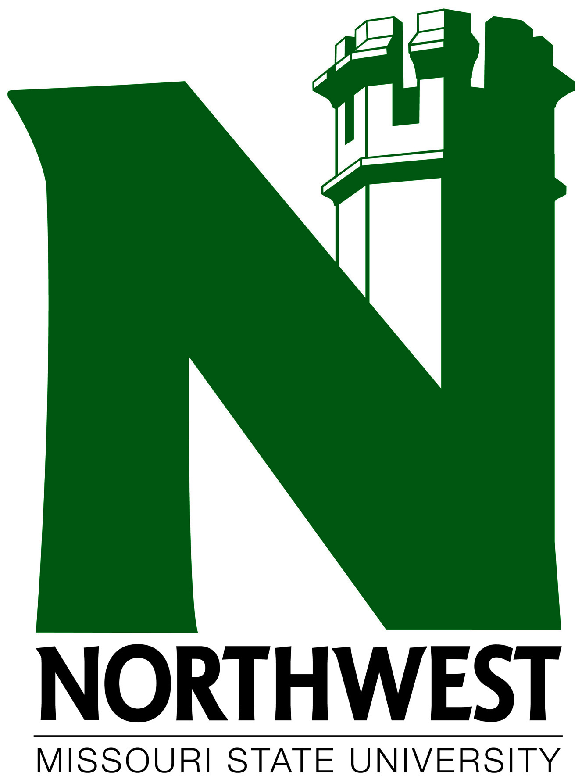
Professional Development 816-736-6618
Graduate Office 660-562-1145
Bursar’s Office 660-562-1578

